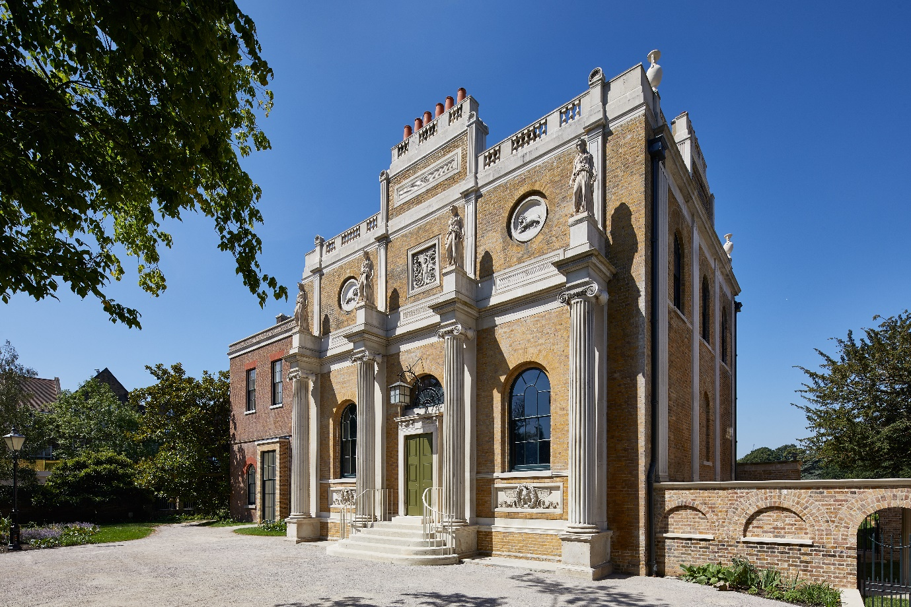
Pitzhanger Manor & Gallery Trust is seeking new Trustees to join its Board at this exciting moment in its development since Pitzhanger re-opened to the public in March 2019, following a major renovation project, and then re-opened again in May 2021 after the COVID lockdown. Pitzhanger Manor is the Grade I listed country house of influential British architect Sir John Soane, designed and built by Soane 1800-1804 in what was then rural Ealing, West London. The award-winning £12m NLHF & ACE-supported renovation project restored the Manor to Soane’s original designs and upgraded the adjacent Gallery – a project that was selected as one of the best restorations of the decade by Country Life, 2019.
The Trust’s vision is to build on the dual foundations of the historic manor and its contemporary programme of exhibitions to inspire its communities in art architecture and design. Since opening Pitzhanger has welcomed many thousands of visitors, run a varied programme of events and workshops, and received excellent reviews from the public and the press. Its programme of exhibitions and events is supported by its fundraising campaigns and retail operations (including private hire, catering and a shop). Anish Kapoor inaugurated the new gallery with an acclaimed exhibition of mirror sculptures, setting the tone for the ambitious programme of exhibitions to follow which have included Es Devlin, Julian Opie and Rana Begum RA.
Having successfully taken Pitzhanger to opening and through the challenges of COVID the Trust is now seeking new Trustees to guide Pitzhanger through the next period of its development, as it rebuilds post pandemic, broadens its reach to new audiences, expands its education and outreach activities, continues the momentum of its exhibition programme, develops new sources of fundraising and strengthens its operational resilience. The Trust is looking for energetic Trustees with broad experience who are passionate about the arts and heritage, and the benefits both can bring to the community; are keen to get involved in a project where their advice can have real impact; and who are sensitive to the challenges of developing dynamic business opportunities in a cultural context. We are also looking for these three specific areas of skills and experience: -
- Fundraising
- Retail (catering, shop, events and private hire, etc)
- Legal and governance
- Communications
- Learning & outreach (whether from a schools or museum/gallery perspective)
To arrange an informal discussion with the Chair about the role please email pitzhanger@pitzhanger.org.uk
If you are excited by the opportunity to work with Pitzhanger to help it achieve its aspirations please send your CV, plus a covering letter (max. 2 sides A4) summarising how your skills could support Pitzhanger, to: pitzhanger@pitzhanger.org.uk

